Abstract
ISWC2004 Poster Abstract Format Instructions*
Jeremy Carroll
Hewlett-Packard Labs,
Bristol, UK
jeremy.carroll@hp.com
The collection of ISWC2004 Poster Abstracts will be printed from electronic manuscripts submitted by the authors. This paper gives the style instructions.
1 Introduction
The ISWC2004 Poster Abstracts will be printed from electronic manuscripts submitted by the authors. These must be PDF (Portable Document Format) or Postscript files formatted for A4 paper.
1.1 Length of Papers
Each accepted poster abstract is allowed two pages.

1.2 Word Processing Software
As detailed below, ISWC has prepared and made available a set of LaTEX macros and a MS-Word template for use in formatting your paper, based on earlier templates prepared for IJCAI. If you are using some other word processing software (such as WordPerfect, etc.), please follow the format instructions given below and ensure that your final paper looks as much like this sample as possible.
2 Style and Format
LaTEX and Word style files that implement these instructions can be retrieved electronically. (See Appendix A for instructions on how to obtain these files.)
2.1 Layout
Print manuscripts two columns to a page, in the manner in which these instructions are printed. The dimensions for pages are:
- left and right margins: .75"
- column width: 3.25"
- gap between columns: .25"
- top margin-first page: 1.375"
- top margin-other pages: .625"
- bottom margin: 1.375"
- column height-first page: 7.125"
- column height-other pages: 9.5"
All measurements assume an A4 page size. There are small rounding errors with the imperial distances
given above, which can be ignored..
2.2 Format of Electronic Manuscript
For the production of the electronic manuscript you must use Adobe’s Portable Document Format (PDF) or Postscript. For example, a PDF can be produced by using Adobe’s Distiller. On UNIX systems, you can use ps2pdf. For reasons of uniformity, Adobe’s Times Roman font is strongly suggested. Additionally, it is of utmost importance to specify A4 format (corresponding to 8.27 x 11.69") when formatting the paper. Otherwise the paper is not printable.
To produce an A4 postscript file using MS-Word, with a Windows OS, the following may be helpful.
You need to have a postscript printer driver. One choice is to use the Adobe Generic Postscript driver, which can be downloaded from:
http://www.adobe.com/support/downloads/
product.jsp?product=44&platform=Windows
If installing this, and you do not have a postscript printer, choose the file printer, as follows:
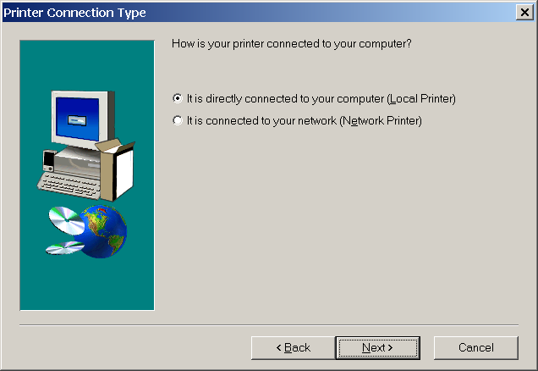
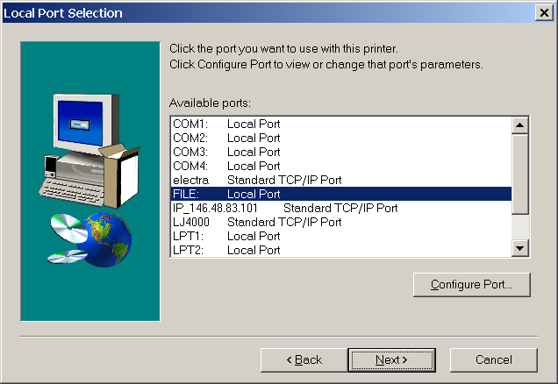

Having installed the driver, or using a postscript driver, that was already installed, you proceed as follows. The dialog boxes shown are for the Adobe driver, a different driver may present similar choices in a different manner.

- Select “Print” from the “File” menu, and choose a postscript printer, and check the “Print to file” option
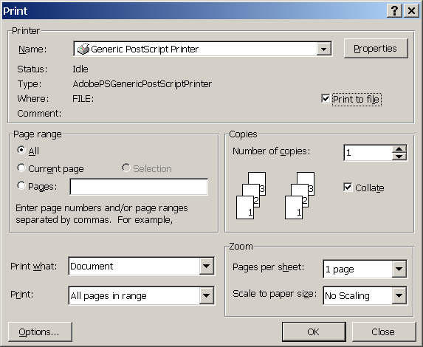
- Click on “Properties”
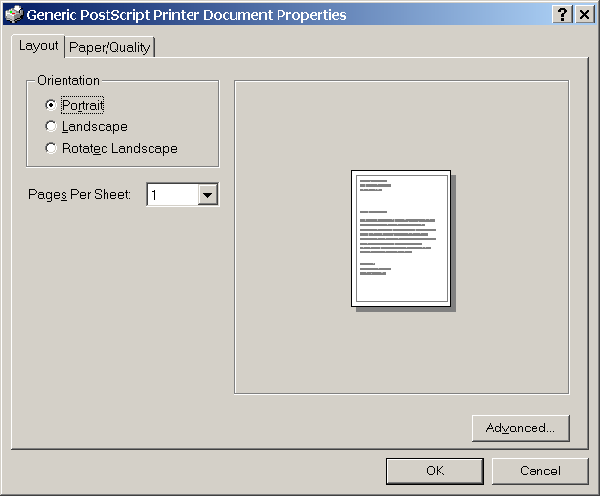
- With this driver, it is necessary to select an “Advanced…” option to chose A4.
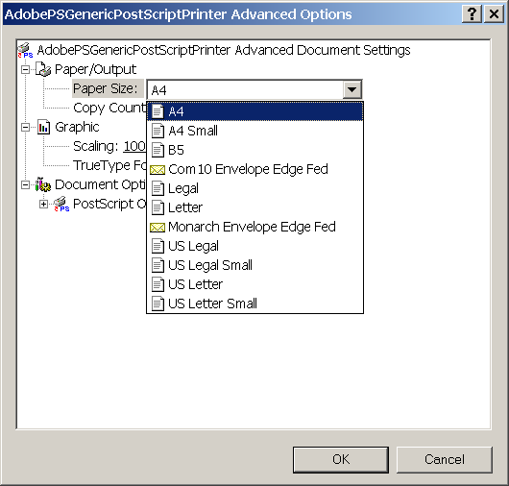
- Find a paper size option, and choose A4
- OK, OK, OK
- You are now prompted for a filename, with “.prn” extension, to which the postscript is output.
- The file extension can be changed to “.ps” afterwards. (Some other postscript drivers will also include some initial and trailing PJL in the output file. Most postscript tools know to ignore this. It is also possible to edit the file by hand, if necessary)
- At this stage you should verify the postscript using a postscript viewer, such as ghostview: http://www.cs.wisc.edu/~ghost/gsview/
- Using this it is possible to convert your file into PDF (use “File”/”Convert…”), which is the preferred submission format.
2.3 Title and Author Information
Center the title on the entire width of the page in a 14-point bold font. Below it, center the author name(s) in a 12-point bold font. Then the address(es) should be centered using a 12-point font. Credit to a sponsoring agency can appear on the first page as a footnote.
2.4 Abstract
Place the abstract at the beginning of the first column 3.0'' from the top of the page, unless that does not leave enough room for the title and author information. Use a slightly smaller width than in the body of the paper. Head the abstract with “Abstract” centered above the body of the abstract in a 12-point bold font. The body of the abstract should be in the same font as the body of the paper.
The abstract should be a concise, one-paragraph summary describing the general thesis and conclusion of your paper. A reader should be able to learn the purpose of the paper and the reason for its importance from the abstract. The abstract should be no more than 100 words long.
2.5 Text
The main body of the text immediately follows the abstract. Use 10-point type in a clear, readable font with 1-point leading (10 on 11).
Indent when starting a new paragraph, except after major headings.
2.6 Headings and Sections
When necessary, headings should be used to separate major sections of your paper. (These instructions use many headings to demonstrate their appearance---your paper should have fewer headings.)
Section Headings
Print section headings in 12-point bold type in the style shown in these instructions. Leave a blank space of approximately 10 points above and 4 points below section headings. Number sections with arabic numerals.
Subsection Headings
Print subsection headings in 11-point bold type. Leave a blank space of approximately 8 points above and 3 points below subsection headings.Number subsections with the section number and the subsection number (in arabic numerals) separated by a period.
Subsubsection Headings
Print subsubsection headings in 10-point bold type. Leave a blank space of approximately 6 points above subsubsection headings. Do not number subsubsections.
Special Sections
You may include an acknowledgements section, including acknowledgments of help from colleagues, financial support, and permission to publish.
Any appendices directly follow the text and look like sections, except that they are numbered with capital letters instead of arabic numerals.
The references section is headed “References,” printed in the same style as a section heading, but without a number. A sample list of references is given at the end of these instructions. Use a consistent format for references, such as provided by BibTEX. The reference list should not include unpublished work.
2.7 Citations
Citations within the text should include the author's last name and the year of publication, for example [Gottlob, 1985]. Append lowercase letters to the year in cases of ambiguity. Treat multiple authors as in the following examples: [Abelson et al., 1985] (for more than two authors) and [Brachman and Schmolze, 1985] (for two authors). If the author portion of a citation is obvious, omit it, e.g., Levesque [1984b]. Collapse multiple citations as follows: [Levesque, 1984a; Haugeland,1981].
2.8 Footnotes
Place footnotes at the bottom of the page in a 9-point font. Refer to them with superscript numbers. Separate them from the text by a short line. Avoid footnotes as much as possible; they interrupt the flow of the text.
3 Illustrations
Place illustrations (figures, drawings, tables, and photographs) throughout the paper at the places where they are first discussed, rather than at the end of the paper. If placed at the bottom or top of a page, illustrations may run across both columns. Illustrations must be rendered electronically or scanned and placed directly in your document pages.
All illustrations should be in black and white since color illustrations may cause problems. Line weights should be 1/2-point or thicker. Avoid screens and superimposing type on patterns as these effects may not reproduce well.
Number illustrations sequentially. Use references of the following form: Figure 1, Table 2, etc. Place illustration numbers and captions under illustrations. Leave a margin of 1/4-inch around the area covered by the illustration and caption. Use 9-point type for captions, labels, and other text in illustrations.
Acknowledgments
This document is based on the ``IJCAI'03 Formatting Instructions'' by Daniel Pagenstecher.
The preparation of these instructions and the LaTEX and BibTEX files that implement them was supported by Schlumberger Palo Alto Research, AT&T Bell Laboratories, and Morgan Kaufmann Publishers. Preparation of the MS Word file was supported by IJCAI.
A Using Word
This MS Word document implements these instructions and can be used as a template.
It is ISWC2004-poster.doc which is currently available at the isc2004.semanticweb.org portal under the call for posters. As this file may be changed to fix bugs, you should ensure that you are using the most recent version.
Further information on using the style file for the preparation of poster abstracts for ISWC2004 can be obtained by contacting jeremy.carroll@hp.com.
References
[Abelson et al., 1985] Harold Abelson, Gerald Jay Sussman, and Julie Sussman. Structure and Interpretation of Computer Programs. MIT Press, Cambridge, Massachusetts, 1985.

[Brachman and Schmolze, 1985] Ronald J. Brachman and James G. Schmolze. An overview of the KL-ONE knowledge representation system. Cognitive Science, 9(2):171--216, April--June 1985.

[Gottlob, 1992] Georg Gottlob. Complexity results for nonmonotonic logics.Journal of Logic and Computation, 2 (3):397-425, June 1992.

[Haugeland, 1981] John Haugeland, editor. Mind Design. Bradford Books, Montgomery, Vermont, 1981.

[Lenat, 1981] Douglas B. Lenat. The nature of heuristics. Technical Report CIS-12 (SSL-81-1), Xerox Palo Alto Research Centers, April 1981.

[Levesque, 1984a] Hector J. Levesque. Foundations of a functional approach to knowledge representation. Artificial Intelligence, 23(2):155--212, July 1984.

[Levesque, 1984b] Hector J. Levesque. A logic of implicit and explicit belief. In Proceedings of the Fourth National Conference on Artificial Intelligence, pages 198--202, Austin, Texas, August 1984. American Association for Artificial Intelligence.

This is how your footnotes should appear.
Note the line separating these footnotes from the text.

